Harrington Park Historical Society
Meetings and Events
2022-2023

The Harrington Park Historical Society holds General Meetings the first Monday of every month (except where otherwise noted) September through June in the Harrington Park Library (second floor). The meetings begin at 7:30 P.M. and include a lecture by a guest speaker on various topics of history, followed by a reception. Our meetings are open to everyone.

The Harrington Park Historical Society is a non-profit 501(c)(3) Corporation

September 12, 2022– General Meeting

Speaker: James Calaski, Lecturer, Historian
Topic: “A Nazi Spy from Glen Rock, and the American Bund”

October 3, 2022– General Meeting

Speaker: Pat Schuber, Historian, Author, Professor
Topic: “The Lincoln-Douglas Debates”

October 30, 2022 – Tales of the Old Burying Ground

November 7, 2022 – General Meeting

Speaker: Mickey DiCamillo, Archivist, Historian, Author
Topic: “When There Were Witches; An Exploration of the Salem Witch Trials”

December 4/5, 2022 – Holiday Outing

Speaker: Mary Cardenas, Director Orangetown Museum, Historian
Tour of Orangetown Museum & Reception

January 2, 2023– General Meeting

Speaker: Herbert S. Gold, U.S. Army Air Force, Eighth Air Force, 705th Bomb Squadron of the 446th Bomb Group flying in a B-24
Topic: Posthumous Reflections of WW 11 Prisoner of War, Herbert S. Gold – Salute to Our Vets

February 6, 2023 – General Meeting

Speaker: Glenn LeBoeuf, Historian
Topic: “Eight Moral Moments in the Life of Abraham Lincoln”

March 6, 2023– General Meeting

Speaker: Eric Nelsen, Director of historic Kearney House, Historical Interpreter, Historian
Topic: “The Yonkers-Alpine Ferry”

April 3, 2023

Speaker: Mario Medici, Historian, Lecturer, Owner of Medici Tours
Topic: “Ellis Island”

April 29, 2023 - History Day

10:00 A.M. – Noon at HP Boro Hall - An Exhibition of Town History. Society Collects Artifacts and Papers

May 1, 2023
Speaker: Various Long-Time Residents of HP
Topic: “Tea and Tales”

June 5, 2023 – General and Society

Speaker: Carol Simon Levin, Author, Historian, Lecturer
Topic: “Crazy Daisy”

June 10, 2023 – “Members’ Pot Luck Picnic” - 4:00 P.M. at Gerri Gibney’s

Special Note:
Please check our web site for Arts Council Events during the 2021-2023 season. We are anticipating several concerts!

Proud Sponsor of the
Harrington Park Arts Council
"The Art of Today - The History of Tomorrow!"

A Legacy Project of the HPHS for the 350th Anniversary of the
State of New Jersey

Membership Information
Membership is open to all who are interested in the aims of the Society

Annual Dues:

Individual $20.00
Family $25.00
Youth $5.00 (under 18)

Please note members receive a discount on all Society Events and Activities.

Listed below are Volunteer Opportunities. As a member you can enjoy our lectures, or you might feel the need to be more “hands-on” – it is up to you.

Volunteer Opportunities
1. Docent – The Society has “History Hikes” as well as tours of historical homes and neighborhoods. If you enjoy people, and learning local history – this is for you.
2. Archivist – One of our primary functions is to preserve and catalog the history of Harrington Park.
3. Research – Plenty of opportunity here, either on your own or as part of a group for a specific project.
4. Hosts and Hostesses – Volunteers to prepare and serve refreshments are always needed at the membership meetings and special events.
5. H.P. Society Newsletter Author – The editor of the Society Newsletter welcomes articles of local historical interest, as well as personal recollections of earlier days in H.P.
6. Special Projects – This will include the preservation of the Old Burying Ground and Perry Cemeteries, as well as other endeavors.
7. Other – Let us know how you would like to help, and your area of expertise.

Mailing Address and Contacts

Mailing address for all correspondence, membership and donations is:

Harrington Park Historical Society
P.O. Box 105
Harrington Park, N. J. 07640-0105
Visit us on Facebook or
www.harringtonparkhistoricalsociety.com

General Information:
Gerri Gibney, President
201 768-2615
themerchantmouse@aol.com
Membership:
Karen Goddard, Chair
201 666-0566
klgoddard@optonline.net
Cemetery Project:
Lou Apa
(201) 767-8325
louisapa@yahoo.com
Harrington Park
Historical Society
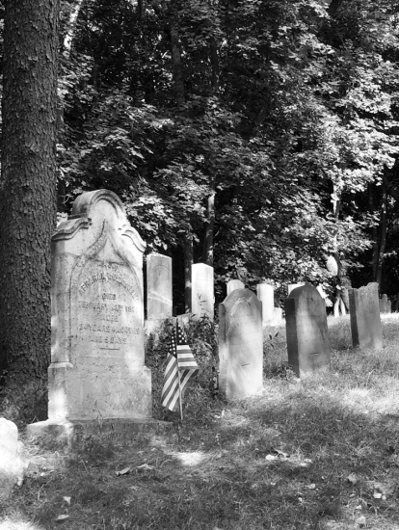

Photo by Dr. Davis Ross
Meetings
and
Events
2022 – 2023

P.O. Box 105
Harrington Park,
N. J. 07640-0105

