PRESS RELEASE
“LOST AMUSEMENT PARKS OF THE NORTH JERSEY SHORE”

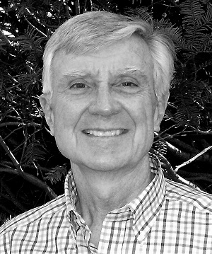

The Harrington Park Historical Society starts off the new Society year with a lecture by Rick Geffken, “Lost Amusement Parks of the North Jersey Shore.” The meeting is on Monday, September 9, 2019, 7:30 P.M. at the Harrington Park Library, 10 Herring Street in Harrington Park.
​
The Jersey Shore has always attracted people seeking relief from summer heat and humidity. Long before Europeans came here, the native Lenape clammed, fished, and played games on the beach and in the surf. These original people could scarcely have imagined that, by the end of the 19th century, the 120-mile-long coastline of New Jersey would be dotted with amusement parks featuring gentle kiddie car rides, terrifying roller coasters, merry-go-rounds, and fast-food emporiums. James Bradley in Asbury Park and William Sandlass Jr. in Highland Beach created mass entertainment for hundreds of thousands of people. Their seaside recreation centers, along with those in Long Branch, Bradley Beach, Pleasure Bay, and others, endured for years but are just fond and fading memories today.

Rick Geffken is an archival historian retired from careers in the computer industry and teaching. He is a member of the Shrewsbury Historical Society as well as the Monmouth County Historical Association. Rick is the former publisher of The Monmouth Connection, the newsletter of the Monmouth County Genealogy Society. Historical and genealogical articles he's written have been published in The Howell Times, the on-line Patch blogs, The Crown newsletter of Christ Episcopal Church in Shrewsbury, and in many other publications. Rick is a well-regarded speaker at many local and state-wide historical societies and preservation conferences. His most recent book for Arcadia Publishing is Lost Amusement Parks of the North Jersey Shore, widely acclaimed during his current book tour.

The Society welcomes everyone to their lectures, all free of charge. After Mr. Geffken’s presentation there will be a Q & A, followed by a light reception. For more information about the Society and its activities, please call Gerri Gibney at 201 768-2615, or go to the Society webpage; www.harringtonparkhistoricalsociety.com, or visit them on Facebook.

----------------------------------

Gerri Gibney
154 LaRoche Avenue
Harrington Park, NJ 07640
201 768-2615
8/16/19

